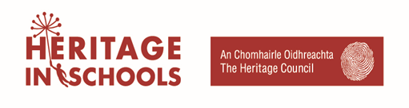

Heritage in Schools Scheme – Application for membership of 2020-2022 Panel of Experts

Applicant Information
Full Name:
 | Last | First

County of residence:

Phone: |  | Email

Have you been a member of the Heritage in Schools Panel in the past? | YES | NO

If yes, what year?:

Professional Background
Please provide a short description of your background under the following headings:

Academic:

Professional Development:

Affiliations:

Area of Expertise

Provide a brief description of the area of Irish heritage you specialise in:

Working with Children

Provide a brief description of any programmes you have worked on involving children in an educational environment:

School Visit Content

Provide a brief overview of what you might cover on a full day visit to a school indicating: a) if the visit could take place outdoors; b) what local heritage topic(s) the visit might focus on; c) How the visit would link with the SESE curriculum.

Location

List the counties you would be willing to travel to with the Scheme:

Capacity to deliver

Give detail on your availability throughout year and how many visits a year you could provide:

References
Please list two professional references.

Full Name:
Organisation: |  | Phone:
Email:
Full Name:
Organisation: |  | Phone:
Email:

Disclaimer and Signature
I certify that my answers are true and complete to the best of my knowledge.

Signature: |  |  | Date:

Data collected will be treated with strict confidentiality and held by the Heritage Council for the duration of the recruitment process or, where applicable, for the life of the 2020-2022 Panel.

Your personal data will not be passed on to any other parties except as necessary for the administration and management of the Heritage in Schools scheme by the Heritage Council.

